Antes de iniciar con todo deben tener creada una cuenta y sus respectiva API_KEY, la cual van a usar para poder acceder a la plataforma y consumir servicios del clima
Explciacion de API
https://www.youtube.com/watch?v=x3k2kd9j79c&ab_channel=ProgramadorE
https://www.sydle.com/es/blog/api-6214f68876950e47761c40e7
PORTAL DE API
https://openweathermap.org/api/one-call-3

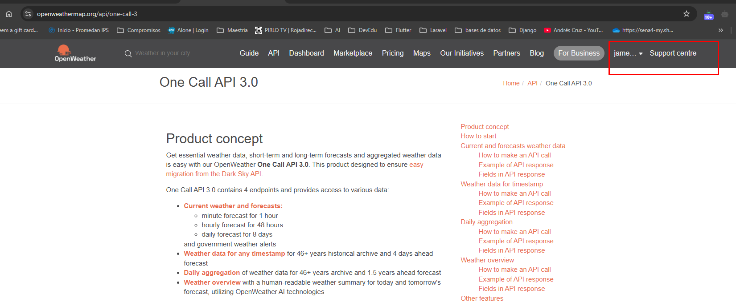

https://home.openweathermap.org/
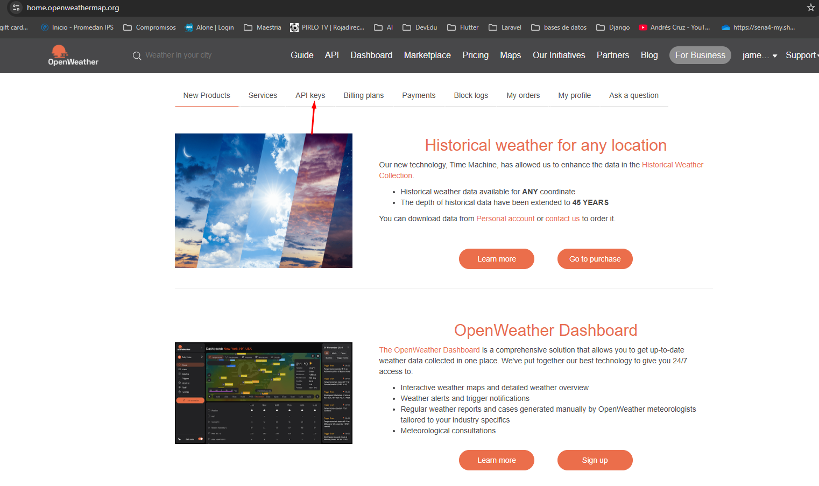

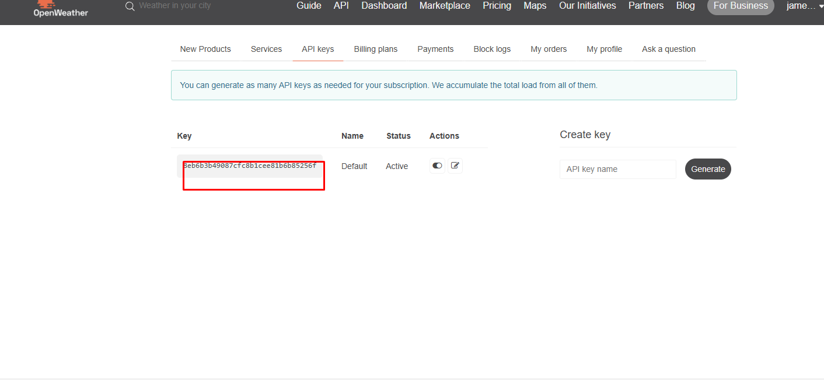
Vas acopiar a y a tener segura ese code, luego la vamos a usar

Vamos a iniciar creando la app. Inicialmente vamos a iniciar con la arquitectura de carpetas
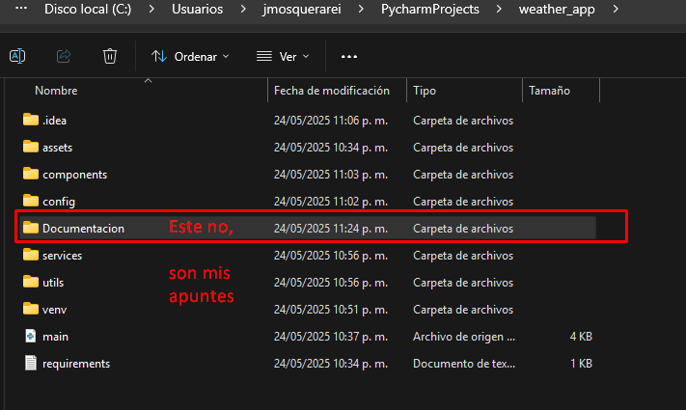

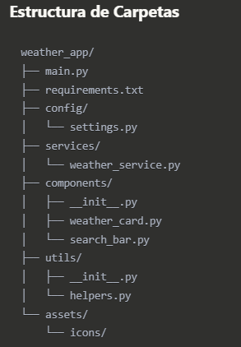
1. requirements.txt
txtflet>=0.21.0
requests>=2.31.0
python-dotenv>=1.0.0

2. config/settings.py
import os
from dotenv import load_dotenv
load_dotenv()
# API Key gratuita de OpenWeatherMap (Current Weather Data API - GRATIS)
WEATHER_API_KEY = os.getenv("WEATHER_API_KEY", "tu_api_key_de_openweathermap")
# URLs para API gratuita (Current Weather Data 2.5 - NO requiere suscripción)
BASE_URL = "https://api.openweathermap.org/data/2.5"
GEOCODING_URL = "https://api.openweathermap.org/geo/1.0"
# URLs para One Call API 3.0 (REQUIERE suscripción de pago)
# ONE_CALL_URL = "https://api.openweathermap.org/data/3.0/onecall"
# Configuración de la app
APP_TITLE = "Clima App"
DEFAULT_CITY = "Medellín"

3. services/weather_service.py
import requests
from config.settings import WEATHER_API_KEY, BASE_URL, GEOCODING_URL
class WeatherService:
def __init__(self):
self.api_key = WEATHER_API_KEY
def get_coordinates(self, city_name):
"""Obtiene las coordenadas de una ciudad"""
try:
url = f"{GEOCODING_URL}/direct"
params = {
"q": city_name,
"limit": 1,
"appid": self.api_key
}
response = requests.get(url, params=params)
response.raise_for_status()
data = response.json()
if data:
return data[0]["lat"], data[0]["lon"]
return None, None
except Exception as e:
print(f"Error obteniendo coordenadas: {e}")
return None, None
def get_weather(self, city_name):
"""Obtiene el clima actual de una ciudad"""
try:
lat, lon = self.get_coordinates(city_name)
if not lat or not lon:
return None
url = f"{BASE_URL}/weather"
params = {
"lat": lat,
"lon": lon,
"appid": self.api_key,
"units": "metric",
"lang": "es"
}
response = requests.get(url, params=params)
response.raise_for_status()
return response.json()
except Exception as e:
print(f"Error obteniendo clima: {e}")
return None
def get_forecast(self, city_name, days=5):
"""Obtiene el pronóstico de varios días"""
try:
lat, lon = self.get_coordinates(city_name)
if not lat or not lon:
return None
url = f"{BASE_URL}/forecast"
params = {
"lat": lat,
"lon": lon,
"appid": self.api_key,
"units": "metric",
"lang": "es"
}
response = requests.get(url, params=params)
response.raise_for_status()
return response.json()
except Exception as e:
print(f"Error obteniendo pronóstico: {e}")
return None

4. utils/helpers.py
def get_weather_icon(weather_code):
"""Devuelve un emoji según el código del clima"""
weather_icons = {
"01d": "☀️", "01n": "🌙",
"02d": "⛅", "02n": "☁️",
"03d": "☁️", "03n": "☁️",
"04d": "☁️", "04n": "☁️",
"09d": "🌧️", "09n": "🌧️",
"10d": "🌦️", "10n": "🌧️",
"11d": "⛈️", "11n": "⛈️",
"13d": "❄️", "13n": "❄️",
"50d": "🌫️", "50n": "🌫️"
}
return weather_icons.get(weather_code, "🌤️")
def format_temperature(temp):
"""Formatea la temperatura"""
return f"{int(temp)}°C"
def capitalize_first(text):
"""Capitaliza la primera letra"""
return text.capitalize() if text else ""

5. components/search_bar.py
import flet as ft
class SearchBar(ft.UserControl):
def __init__(self, on_search):
super().__init__()
self.on_search = on_search
def build(self):
self.search_field = ft.TextField(
hint_text="Buscar ciudad...",
prefix_icon=ft.icons.SEARCH,
on_submit=self.search_city,
expand=True
)
self.search_button = ft.IconButton(
icon=ft.icons.SEARCH,
on_click=self.search_city,
tooltip="Buscar"
)
return ft.Row([
self.search_field,
self.search_button
])
def search_city(self, e):
city = self.search_field.value.strip()
if city:
self.on_search(city)

6. components/weather_card.py
import flet as ft
from utils.helpers import get_weather_icon, format_temperature, capitalize_first
class WeatherCard(ft.UserControl):
def __init__(self):
super().__init__()
def build(self):
# Crear los controles como atributos de la clase
self.city_title = ft.Text(
"Selecciona una ciudad",
size=24,
weight=ft.FontWeight.BOLD,
text_align=ft.TextAlign.CENTER
)
self.weather_icon = ft.Text("🌤️", size=60)
self.temperature = ft.Text("--°C", size=48, weight=ft.FontWeight.BOLD)
self.description = ft.Text("--", size=16)
self.feels_like = ft.Text("--°C", size=16, weight=ft.FontWeight.BOLD)
self.humidity = ft.Text("--%", size=16, weight=ft.FontWeight.BOLD)
self.wind_speed = ft.Text("-- km/h", size=16, weight=ft.FontWeight.BOLD)
return ft.Card(
content=ft.Container(
content=ft.Column([
# Título de la ciudad
self.city_title,
ft.Divider(),
# Información principal del clima
ft.Row([
ft.Column([
self.weather_icon,
], horizontal_alignment=ft.CrossAxisAlignment.CENTER),
ft.Column([
self.temperature,
self.description,
], horizontal_alignment=ft.CrossAxisAlignment.START),
], alignment=ft.MainAxisAlignment.SPACE_AROUND),
ft.Divider(),
# Detalles adicionales
ft.Row([
ft.Column([
ft.Text("Sensación", size=12, color=ft.colors.GREY_600),
self.feels_like,
], horizontal_alignment=ft.CrossAxisAlignment.CENTER),
ft.Column([
ft.Text("Humedad", size=12, color=ft.colors.GREY_600),
self.humidity,
], horizontal_alignment=ft.CrossAxisAlignment.CENTER),
ft.Column([
ft.Text("Viento", size=12, color=ft.colors.GREY_600),
self.wind_speed,
], horizontal_alignment=ft.CrossAxisAlignment.CENTER),
], alignment=ft.MainAxisAlignment.SPACE_AROUND),
]),
padding=20,
border_radius=10,
),
elevation=5,
)
def update_weather(self, weather_data):
"""Actualiza la tarjeta con datos del clima"""
if not weather_data:
return
# Extraer datos
city_name = weather_data.get("name", "")
country = weather_data.get("sys", {}).get("country", "")
temp = weather_data.get("main", {}).get("temp", 0)
feels_like = weather_data.get("main", {}).get("feels_like", 0)
humidity = weather_data.get("main", {}).get("humidity", 0)
wind_speed = weather_data.get("wind", {}).get("speed", 0)
description = weather_data.get("weather", [{}])[0].get("description", "")
icon_code = weather_data.get("weather", [{}])[0].get("icon", "")
# Actualizar contenido usando las referencias directas
self.city_title.value = f"{city_name}, {country}"
self.weather_icon.value = get_weather_icon(icon_code)
self.temperature.value = format_temperature(temp)
self.description.value = capitalize_first(description)
self.feels_like.value = format_temperature(feels_like)
self.humidity.value = f"{humidity}%"
self.wind_speed.value = f"{wind_speed * 3.6:.1f} km/h"
self.update()

7. main.py
import flet as ft
from services.weather_service import WeatherService
from components.weather_card import WeatherCard
from components.search_bar import SearchBar
from config.settings import APP_TITLE, DEFAULT_CITY
class WeatherApp:
def __init__(self, page: ft.Page):
self.page = page
self.weather_service = WeatherService()
self.weather_card = WeatherCard()
self.setup_page()
self.build_ui()
# Cargar clima por defecto
self.search_weather(DEFAULT_CITY)
def setup_page(self):
"""Configura la página principal"""
self.page.title = APP_TITLE
self.page.theme_mode = ft.ThemeMode.LIGHT
self.page.padding = 20
self.page.scroll = ft.ScrollMode.ADAPTIVE
def build_ui(self):
"""Construye la interfaz de usuario"""
# Título de la app
title = ft.Text(
APP_TITLE,
size=32,
weight=ft.FontWeight.BOLD,
text_align=ft.TextAlign.CENTER
)
# Barra de búsqueda
search_bar = SearchBar(on_search=self.search_weather)
# Indicador de carga
self.loading = ft.ProgressRing(visible=False)
# Mensaje de error
self.error_message = ft.Text(
"",
color=ft.colors.RED,
text_align=ft.TextAlign.CENTER,
visible=False
)
# Agregar todos los controles a la página
self.page.add(
ft.Column([
title,
ft.Divider(),
search_bar,
ft.Container(
content=self.loading,
alignment=ft.alignment.center,
height=50
),
self.error_message,
self.weather_card,
],
horizontal_alignment=ft.CrossAxisAlignment.CENTER,
spacing=20)
)
def search_weather(self, city_name):
"""Busca el clima de una ciudad"""
self.show_loading(True)
self.hide_error()
# Obtener datos del clima
weather_data = self.weather_service.get_weather(city_name)
if weather_data:
self.weather_card.update_weather(weather_data)
else:
self.show_error(f"No se pudo obtener el clima de '{city_name}'. Verifica el nombre de la ciudad.")
self.show_loading(False)
def show_loading(self, show):
"""Muestra/oculta el indicador de carga"""
self.loading.visible = show
self.page.update()
def show_error(self, message):
"""Muestra un mensaje de error"""
self.error_message.value = message
self.error_message.visible = True
self.page.update()
def hide_error(self):
"""Oculta el mensaje de error"""
self.error_message.visible = False
self.page.update()
def main(page: ft.Page):
WeatherApp(page)
if __name__ == "__main__":
ft.app(target=main)

Dependecias que se deben instalar para que funcione
pip install flet
pip install flet requests python-dotenv
python -m pip install flet requests python-dotenv
Recuerden que lo ideal es usar el IDE de pycharm para que les construya de manera automática el .venv
Antes de convertir la App A una APK
Habilitar Modo Desarrollador:
Hacer clic derecho en PowerShell → "Ejecutar como administrador"
start ms-settings:developers
y activa
Activa "Modo de desarrollador"
ahora vamos a la terminal del proyecto y en la carpeta raíz ejecutamos el siguiente comando
flet build apk

